SFTP – Downloading data files

The following is a guide on how to download large files that are sent by New Zealand Post to external clients using the SFTP method

- Navigate to the SFTP URL https://ecnftp.co.nz/ecnftp/ Login page should now be displayed on screen (NB: if you access the SFTP site, and the USERNAME field has the user name details and the INITIAL DIRECTORY field has /from-post, enter the PASSWORD and go directly to Step 3)

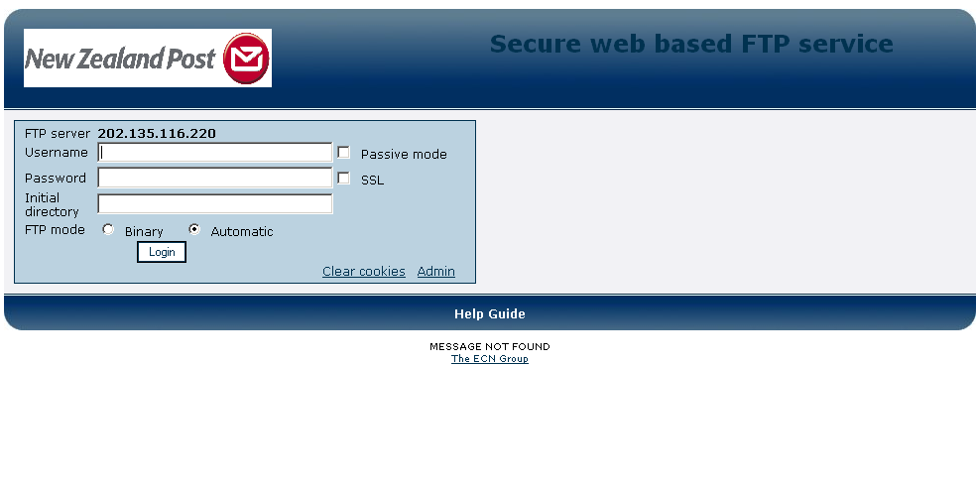
- Enter Username and password details and then click on LOGIN. Main Directory page should now be displayed on screen

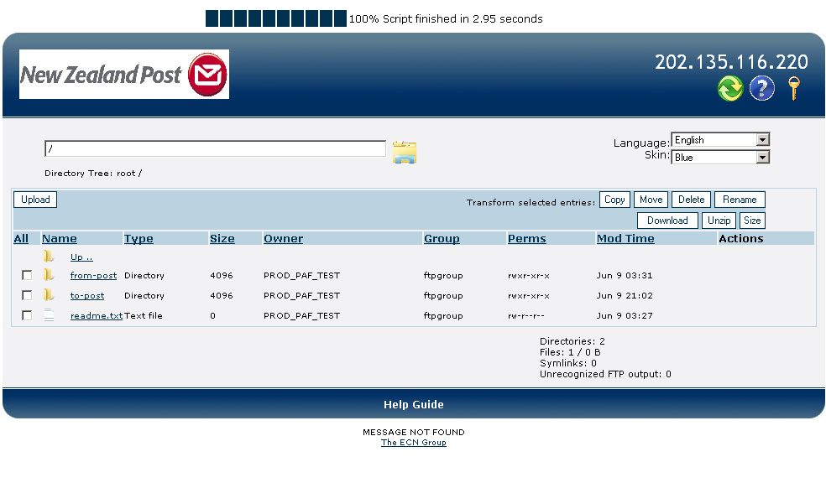

- Click on the FROM POST folder icon. The FROM POST directory should now be displayed on the screen

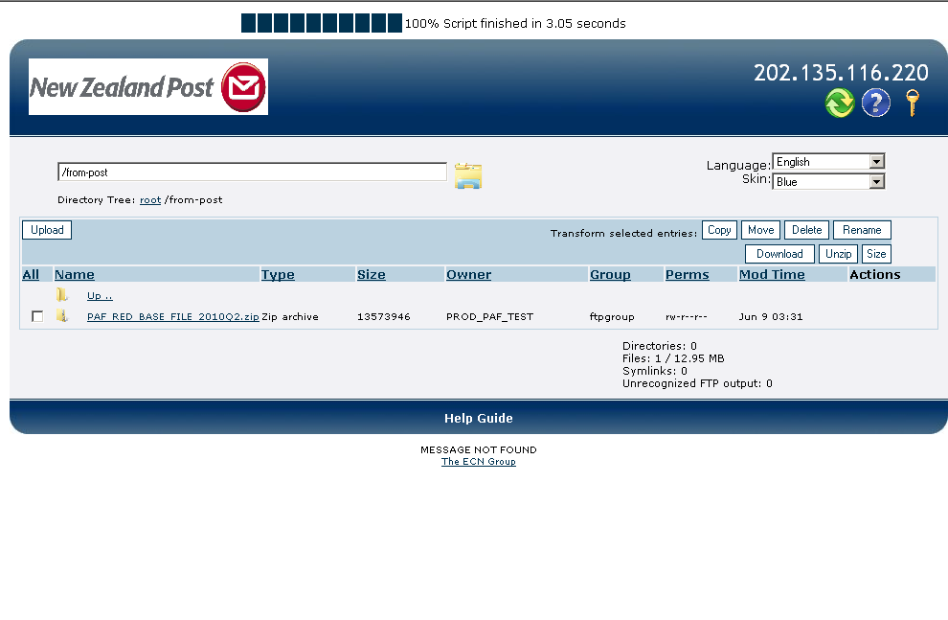

- Navigate your mouse to the empty box beside the file, click to populate the box with a tick and then click DOWNLOAD . A FILE DOWNLOAD dialogue box is displayed on the screen

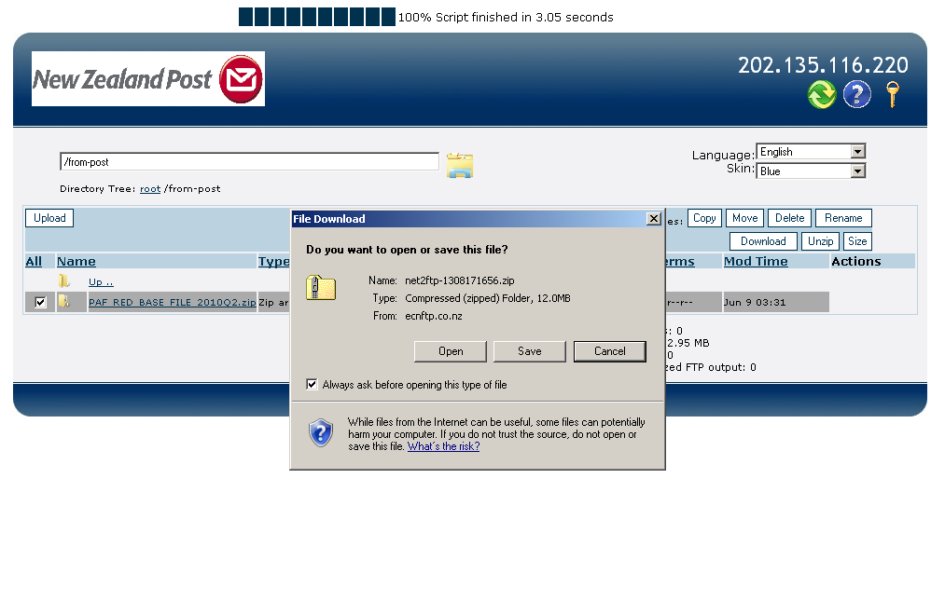

- Click on SAVE, and select where you would like the file to go to on your PC. DOWNLOAD DIALOGUE box now displayed on screen

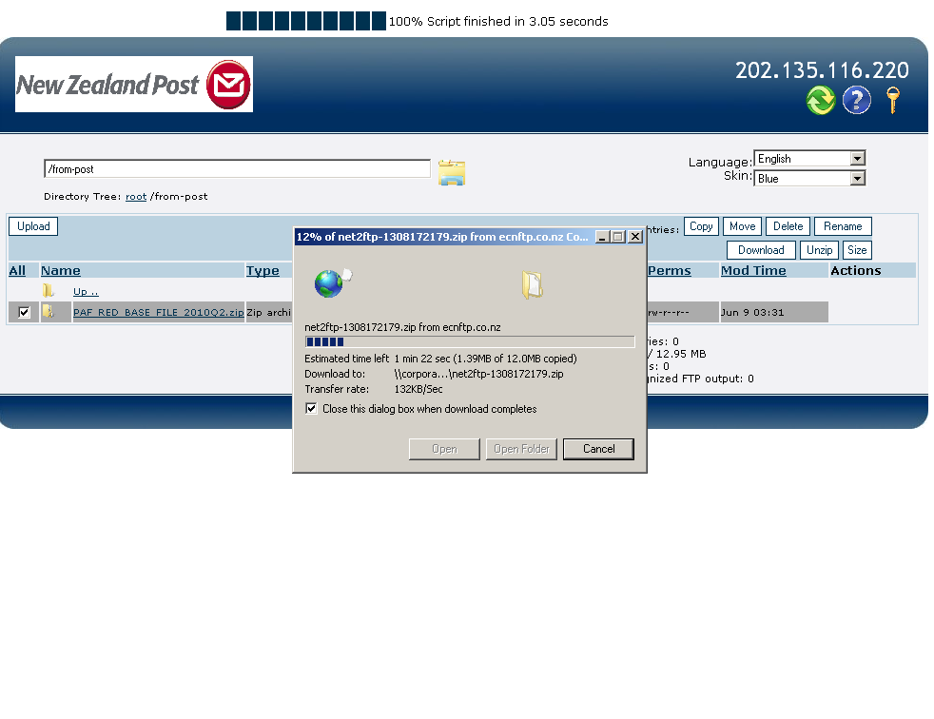

- File should now be downloaded to your location

